# CS 255 System Design Document Template

## UML Diagrams

### UML Use Case Diagram

### UML Activity Diagrams

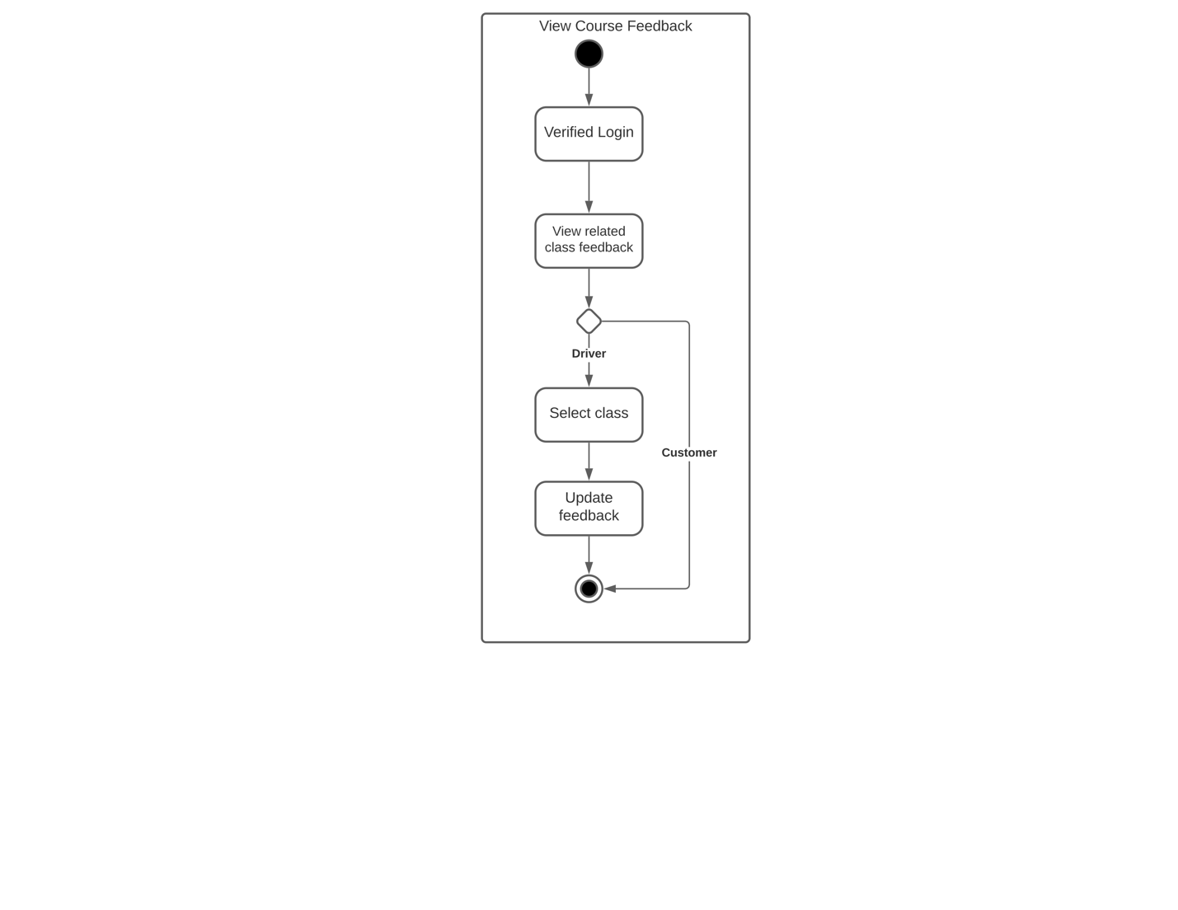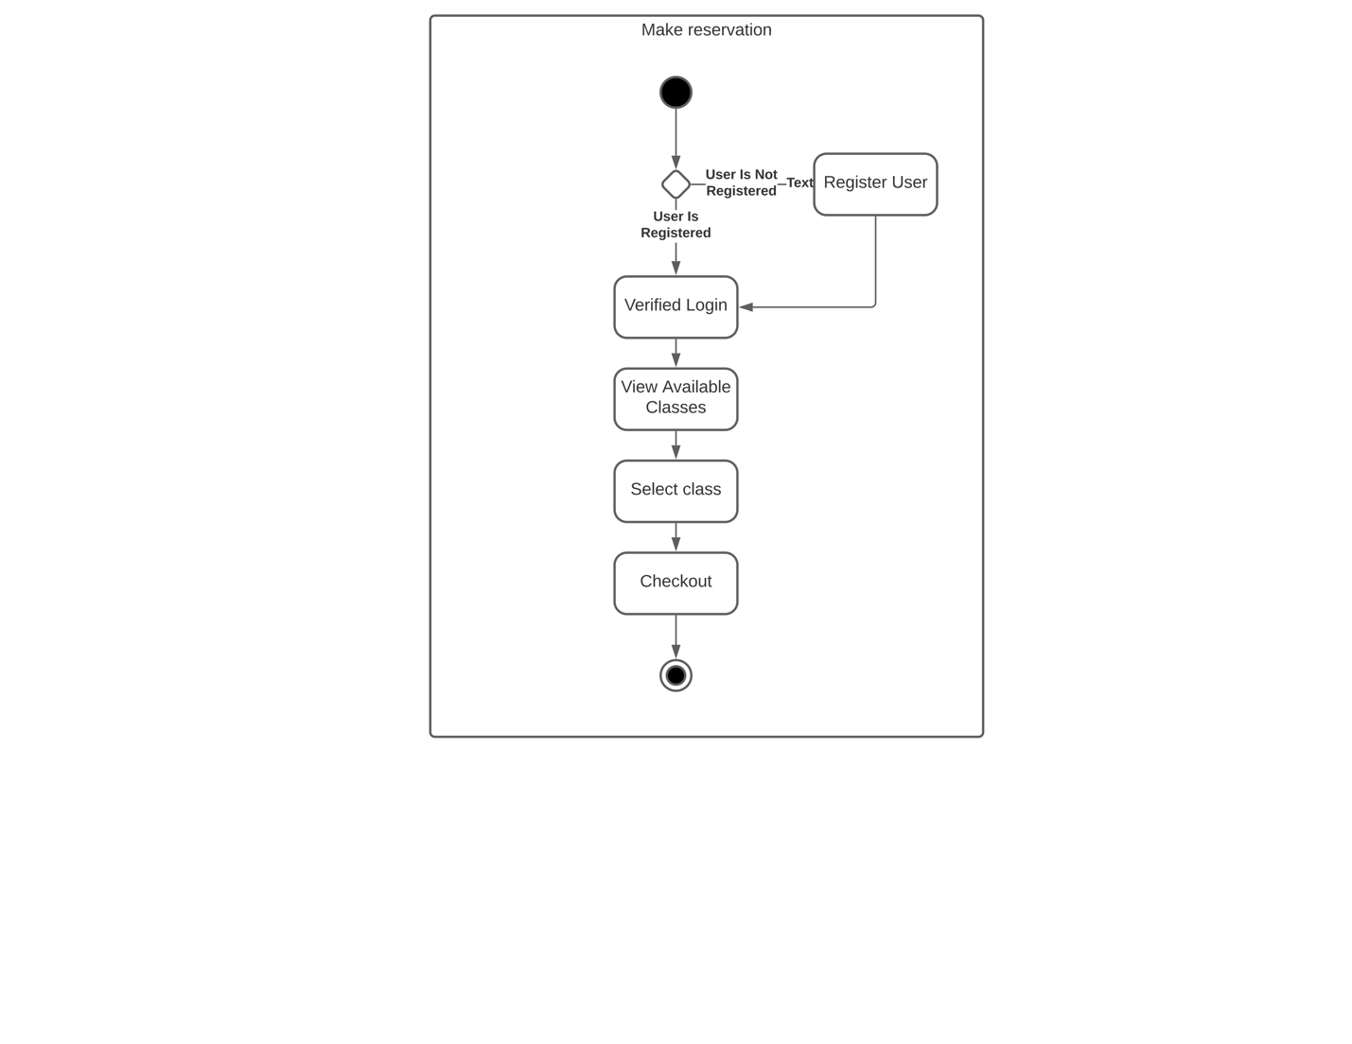

### UML Sequence Diagram

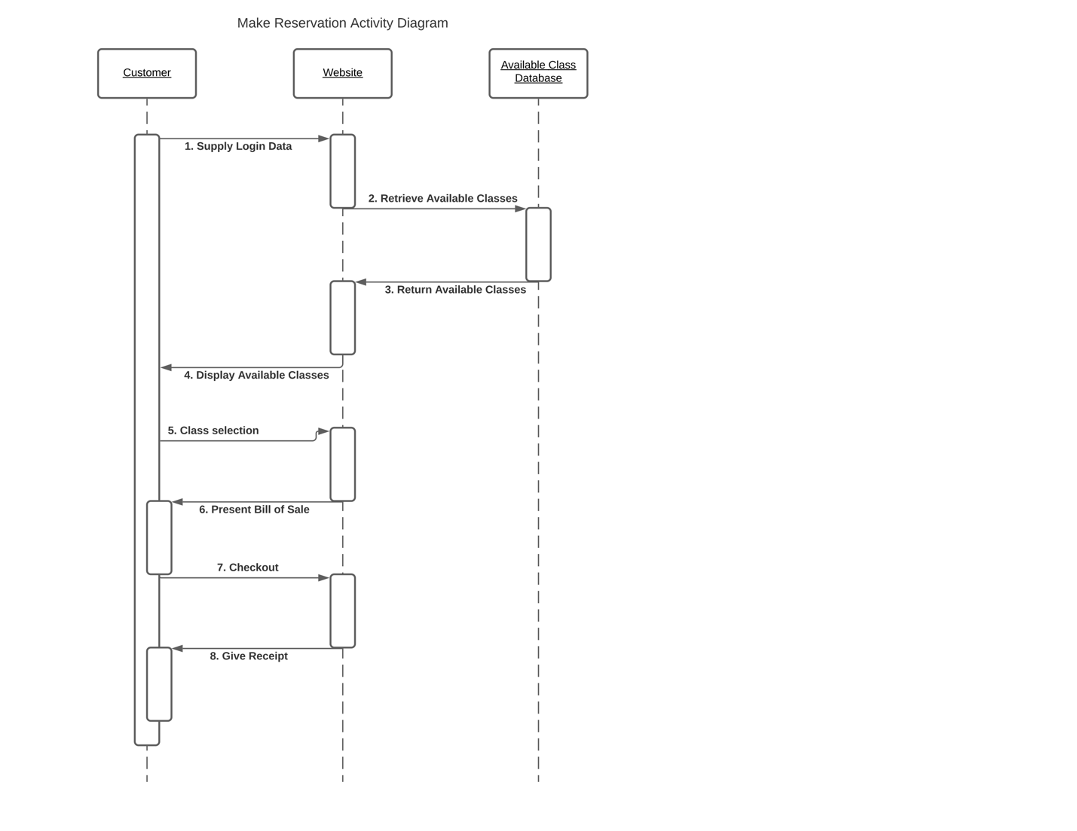

### UML Class Diagram

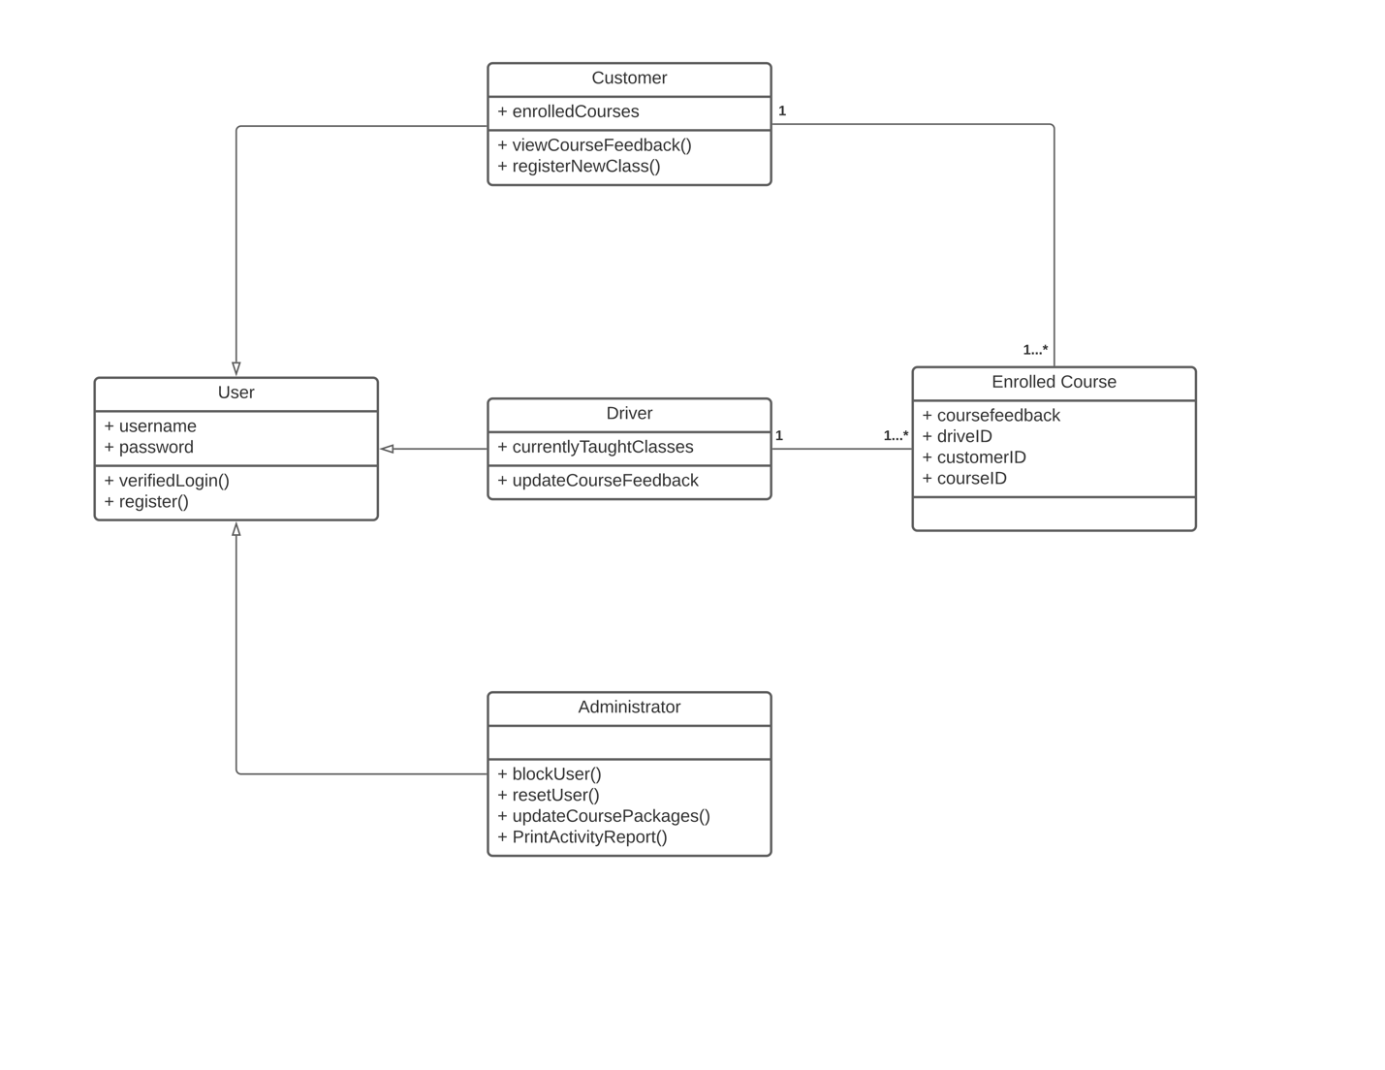

## Technical Requirements

The client side of our system will run inside a web browser, so we need to ensure compatibility with all major browsers and web-based programming languages. We have the freedom of choosing any web-based language we want, but we do need to ensure the language has the proper functionality that we do require. The server side of our system, as well as the various databases we will need, will run and be stored using cloud infrastructure. We should be able to store different DriverPass packages and user information in a cost friendly way. In addition, we need a log that tracks what each user does when interacting with the system, e.g. changing an appointment, leaving feedback, etc.